# The

(hopefully)

# Complete

# Using C++ with Visual Studio Code guide

# Step 1

Download VS Code

[Download Visual Studio Code - Mac, Linux, Windows](https://code.visualstudio.com/Download)

# Step 2

Install VS Code

# Step 3

Enable c++ compiling, instructions can be found here: [C++ programming with Visual Studio Code](https://code.visualstudio.com/docs/languages/cpp)

1. Install extension – this will help the IDE help you. It will not help to compile.

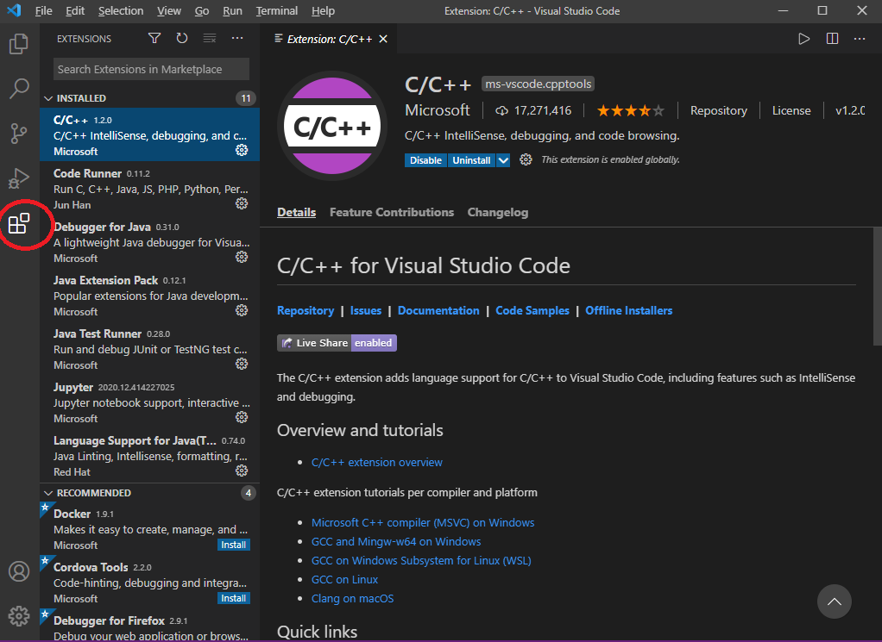

1. Install a compiler. I used MinGW in the example  
   Note the installation directory  
   You can put it where ever you wish  
   [Download MinGW-w64 - for 32 and 64 bit Windows from SourceForge.net](https://sourceforge.net/projects/mingw-w64/files/Toolchains%20targetting%20Win32/Personal%20Builds/mingw-builds/installer/mingw-w64-install.exe/download)
2. Add the c++ bin folder to the path
   1. Type environment in the search box  
      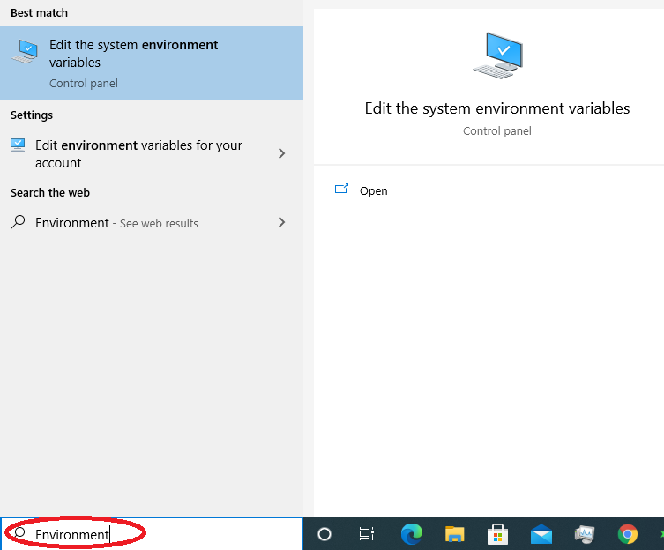
   2. You can hit enter OR click **“**Edit **environment** variables for your account” on the left OR click “Edit the system environment variables” on the right.
   3. If you see the *System Properties* dialog, click **Environment Variables**  
      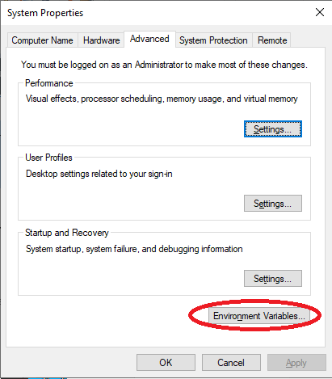
   4. Select the **:Path** environment variable  
      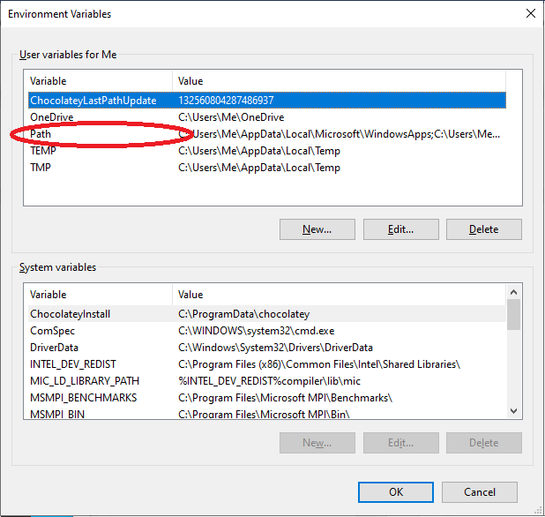
   5. Clcik **Edit**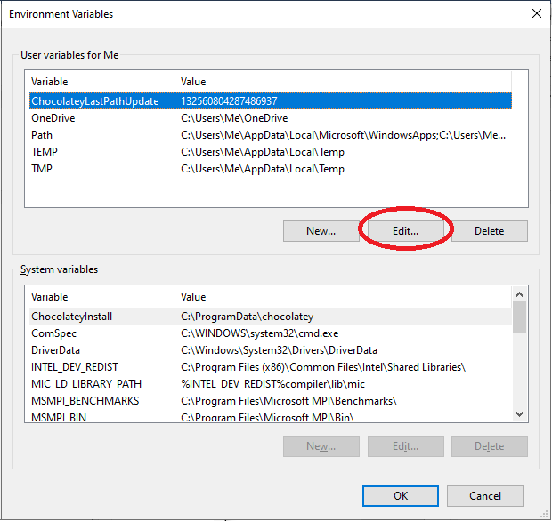
   6. To add a new path double click on a blank line  
      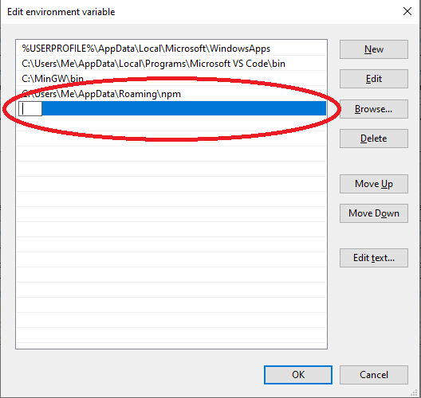
   7. Clicking the **New** button will also add a new path  
      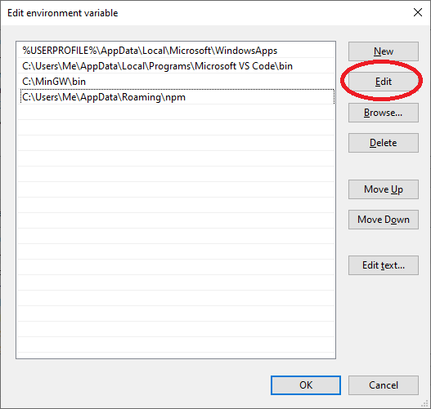
   8. Enter the installation path’s bin folder. This can change between versions so note yours! You can run the install again if you forgot the path. My install points to:  
      C:\Program Files (x86)\mingw-w64\i686-8.1.0-posix-dwarf-rt_v6-rev0  
      The bin folder, containing g++.exe, needs to be added.
3. Compile. Creating the tasks.json is optional. You can if you wish. An easier way is to:
   1. Create a file  
      #include <iostream>  
        
      using namespace std;  
        
      int main()  
      {  
       cout << "Whats up world!" << endl;  
      }
   2. Compile in terminal, the ***o*** parameter indicates output filename  
      g++ *{code file name}* –o *{exe file name}*  
      g++ test.cpp -o test
   3. Run the program (from terminal in vs code)  
      ./test
   4. Run the program (from a command prompt)  
      test

BONUS: [What are the differences between Visual Studio Code and Visual Studio? - Stack Overflow](https://stackoverflow.com/questions/30527522/what-are-the-differences-between-visual-studio-code-and-visual-studio)